


Year 7
Semester 2
Statistical Investigation

Your task is to create an informative poster presentation based on the collection and interpretation of data towards addressing a practical research question for the topic: Indigenous Australian Olympics.

This year you will be required to plan, run and collect data from a traditional Aboriginal game. The 2020 Tokyo Olympics have been postponed. We are going to conduct our own Australian Olympics focusing on Aboriginal and Torres Strait Island games, including Noongar!
.
The poster will be completed in a small group of 3-4 people and selected posters will be entered into a national competition. You are to create a poster (up to 84cm by 59cm) on a sporting event you are allocated. The poster may be presented in either a hard copy or a digital copy. It should be readable from 2 metres away. Your posters will be presented to the class before being sent away for judging in the SSAI competition.

Task Procedure

- Choose a topic question or problem that you will prove or answer using data.

- You will be required to collect primary data and consider what the data represents.

- Complete a plan of action. Use the planning document attached to guide your project to completion.

- State your aim, hypothesis and give some background information.

- Collect the primary data you require by creating a survey.

- It is recommended you include; a table of results and display your data in appropriate various graphical forms such as a; Dot Plot or Stem & Leaf plot.)

- Analyse the data using appropriate techniques (ie mean, median, mode, range, etc)

- Discuss the findings of your data analysis clearly outlining any possible biases or outliers and how you have dealt with these issues.

- Complete your conclusion.

- References

Please refer to attached Marking Rubric for school assessment
For further information about competition rules and also some great example;

https://www.ssaiposercomp.info/

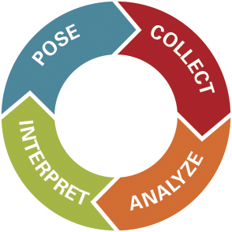

Year 7 Topic: Indigenous Australian Olympics

The topic for Year 7 is Indigenous Australian Olympics. You will be provided with a traditional sport or pastime and design a method of data collection to produce a stem and leaf plot or dot plot. Not only this, but you will get to take part in 6 other games!

To help you get started, here are some topic suggestions.
- Are girls better than boys at Wana?
- Are left handers better than right handers at Diyari Koolchee ?
- Do taller people perform better at Jinnee Ngaman Billee Billee Dabbulgar?
- Are smaller teams or larger teams better at Bowitgee?
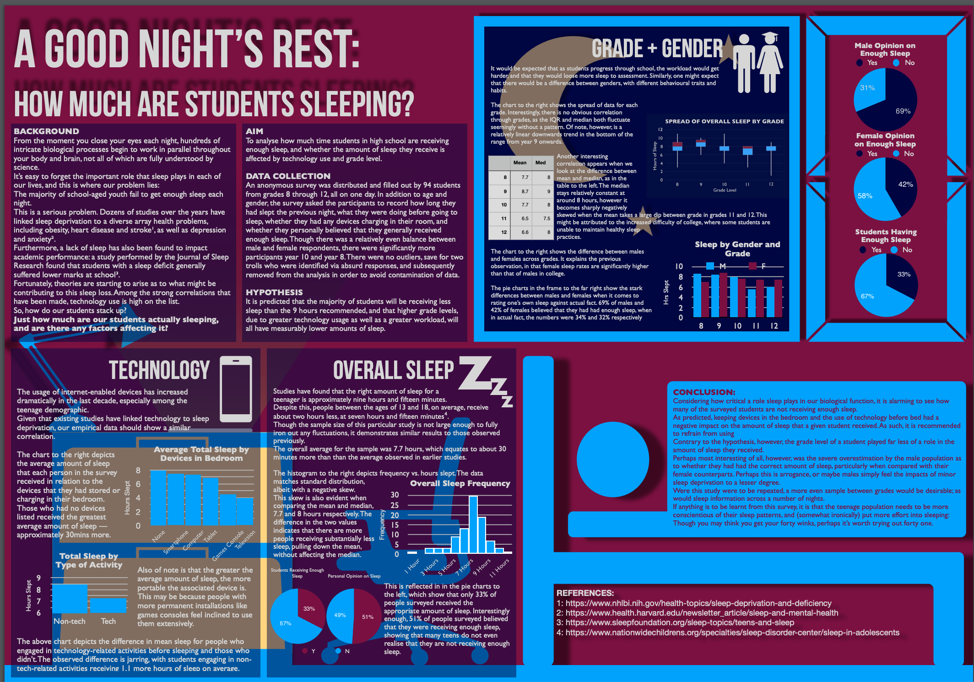
Example

Planning Hints:

A well-considered plan will improve the likely value and success of your project.

Consider the following:

- What equipment do you need to run the event?

- What is the best method for collecting data?

- How are you going to teach other students to participate in the game?

- What background information should our group include about the game and Indigenous background?

- Is there anything that you are aiming to compare or contrast?

POSTER CHECKLIST

- Clarity of the message:
  - Is the poster understandable without extra information?
  - Are the objectives, research question or hypotheses clear?
  - Are the results and conclusions clear?
  - Is the poster clearly and logically set out?

- Data collection:
  - Are the collected data appropriate for answering the research question?
  - Are the data collection methods clearly stated?
  - Has quality of the data been considered? (i.e., accuracy of measurements, size of the sample, reliability of sources, methods of sampling, etc.)
  - Are the data sources referenced in the poster?
  - Are the sporting results included in the table of results?
  - Has bias in your survey question or sample group been considered?

- Graphs and tables:
  - Are the graphs/tables/statistics appropriate for displaying/summarising the data?
  - Are there adequate graphs/tables from different perspectives?
  - Does every graph/ table add something to the poster?
  - Are the graphs/tables properly titled and explained?

- Calculations
  - Have you included statistical calculations? (ie mean, mode, median, range, etc)

- Analysis and conclusions
  - Are the data analysed in terms of the research question or hypotheses?
  - Is the analysis appropriate for the kind of data collected?
  - How well is the research question answered?
  - Are there conclusions and are they supported by the data?
  - Are there any limitations discussed or improvements for future studies suggested?

- Presentation of poster:
  - Is the poster readable from 2 metres (7 feet) away?
  - Is there a good balance between graphs and text?
  - Does the poster look neat?

- Creativity/importance:
  - Is the research question creative, original?
  - Can the study answer an interesting question?
  - Is the design creative and original?
  - Is the poster eye-catching?

- Presentation of poster:
  - Are you prepared to present the poster to the rest of the class?

